**CN Lab**

**Session 2 – Lab 3 (10/12/2020)**

Parthivi Choubey CSE – B - 5th semester

180905456 Roll. no. - 60

**Question 1**

**a.**

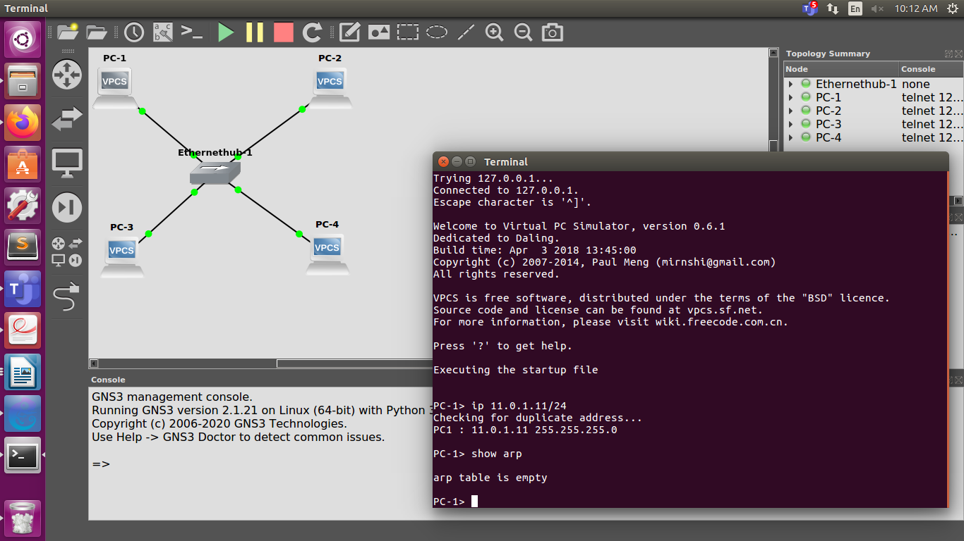

**b.**

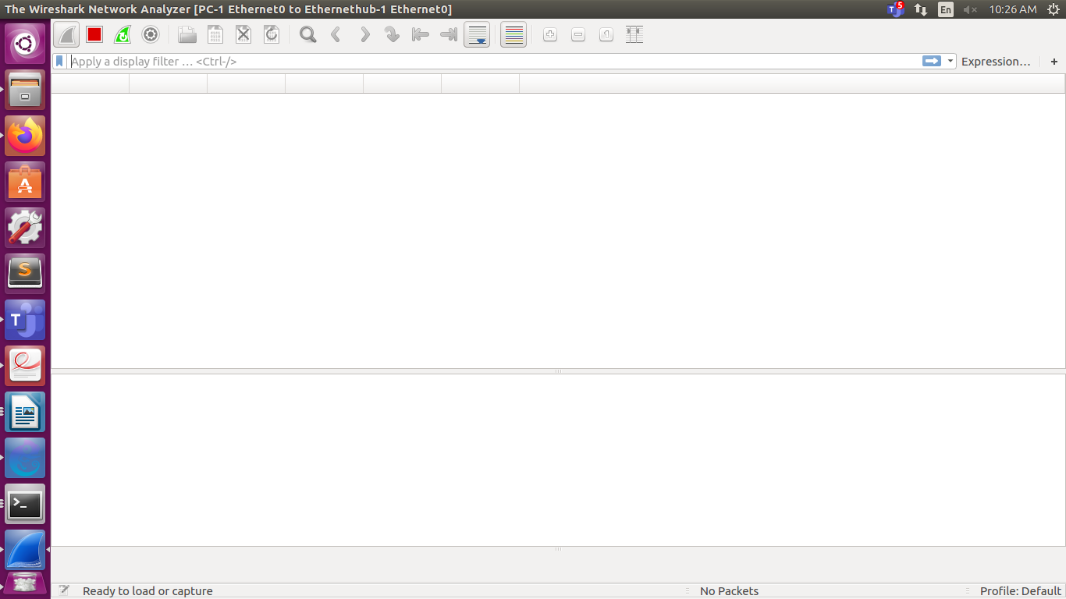

**c.**

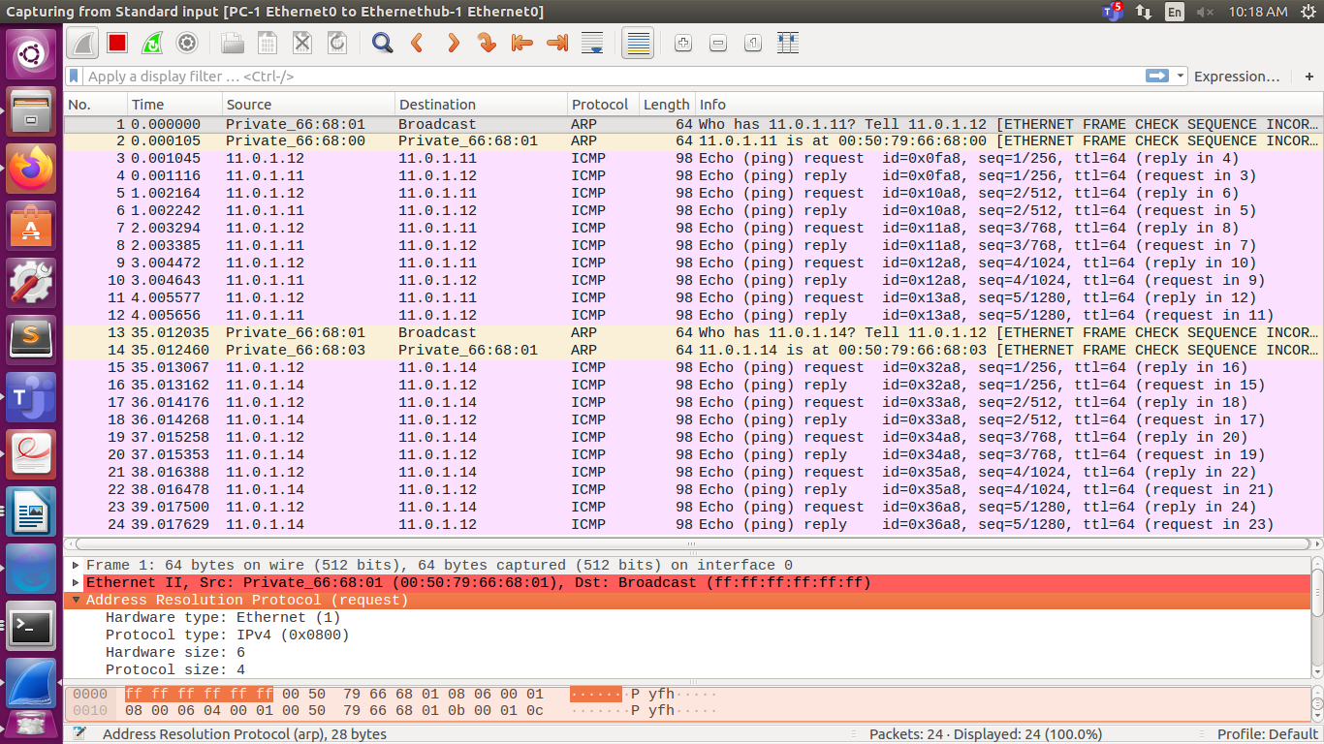

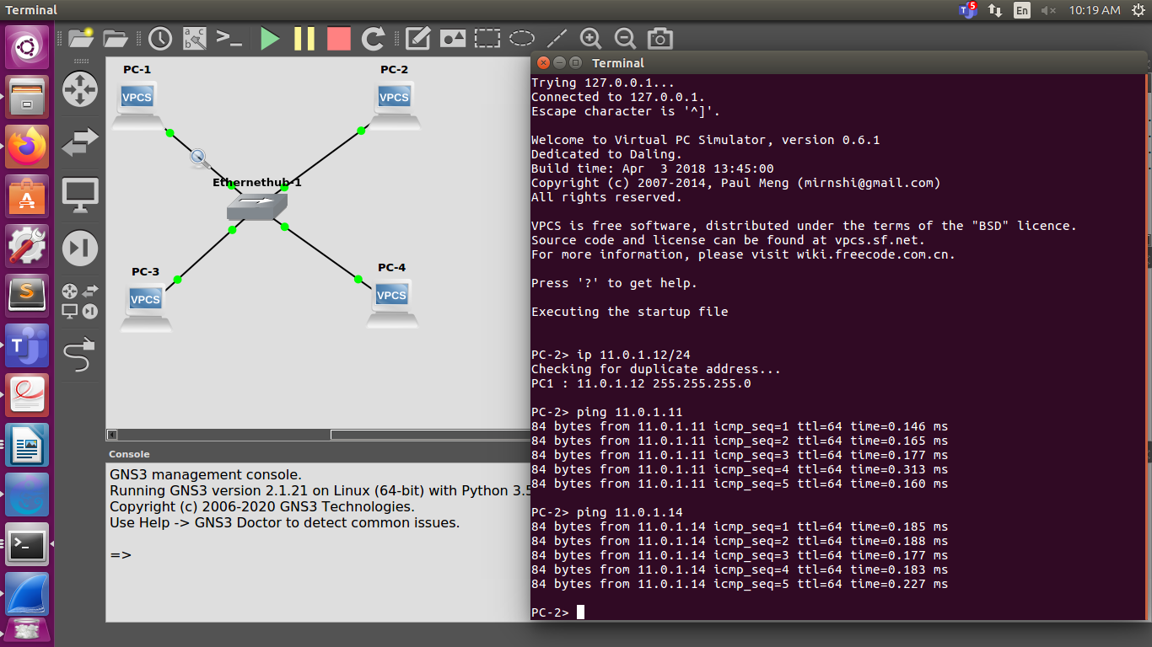

Destination MAC address of ARP request packet:

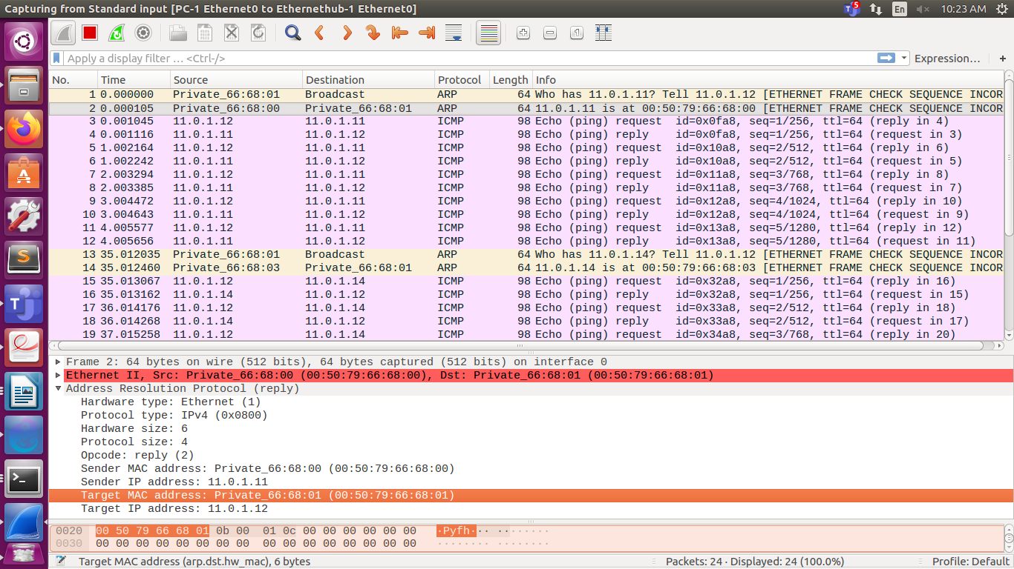

Type field in the ethernet headers of the ARP packets:

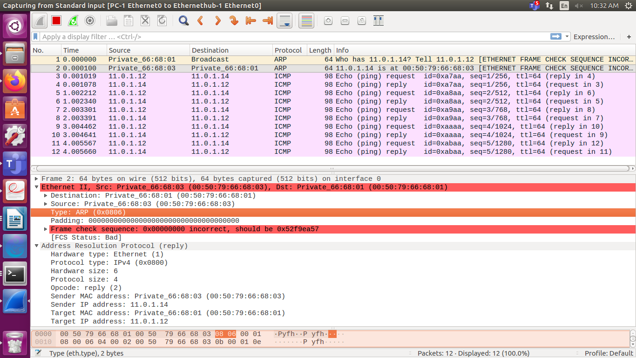

**d.**

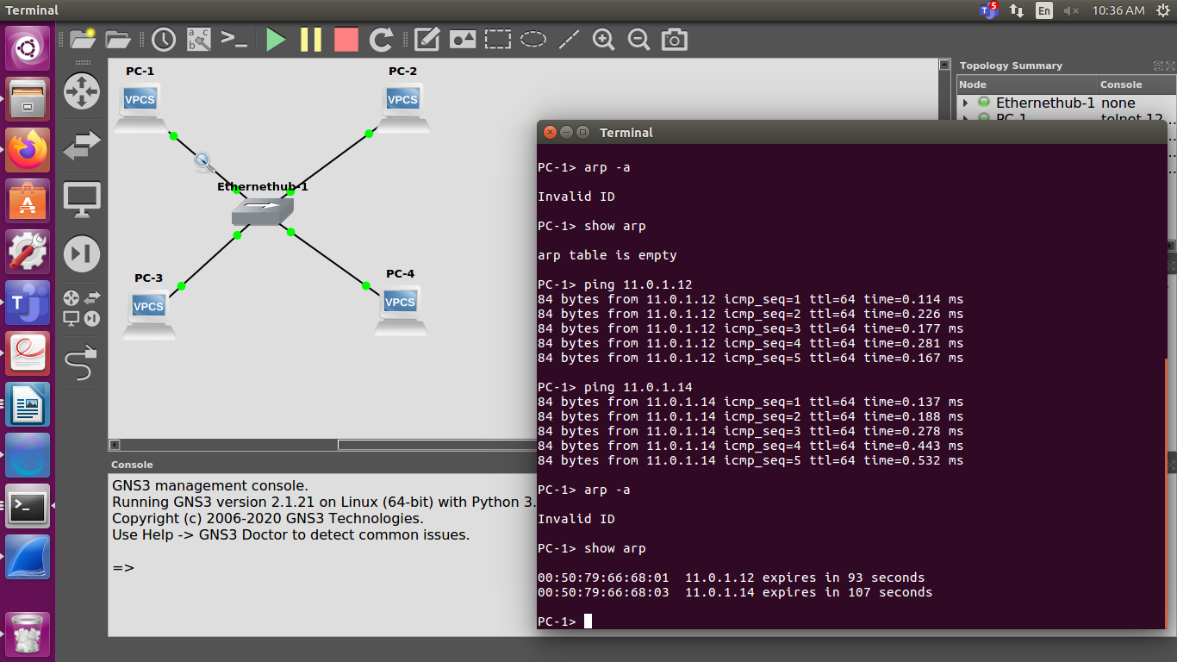

**e.** Uploaded as seperate file

**Question 2**

**i.**

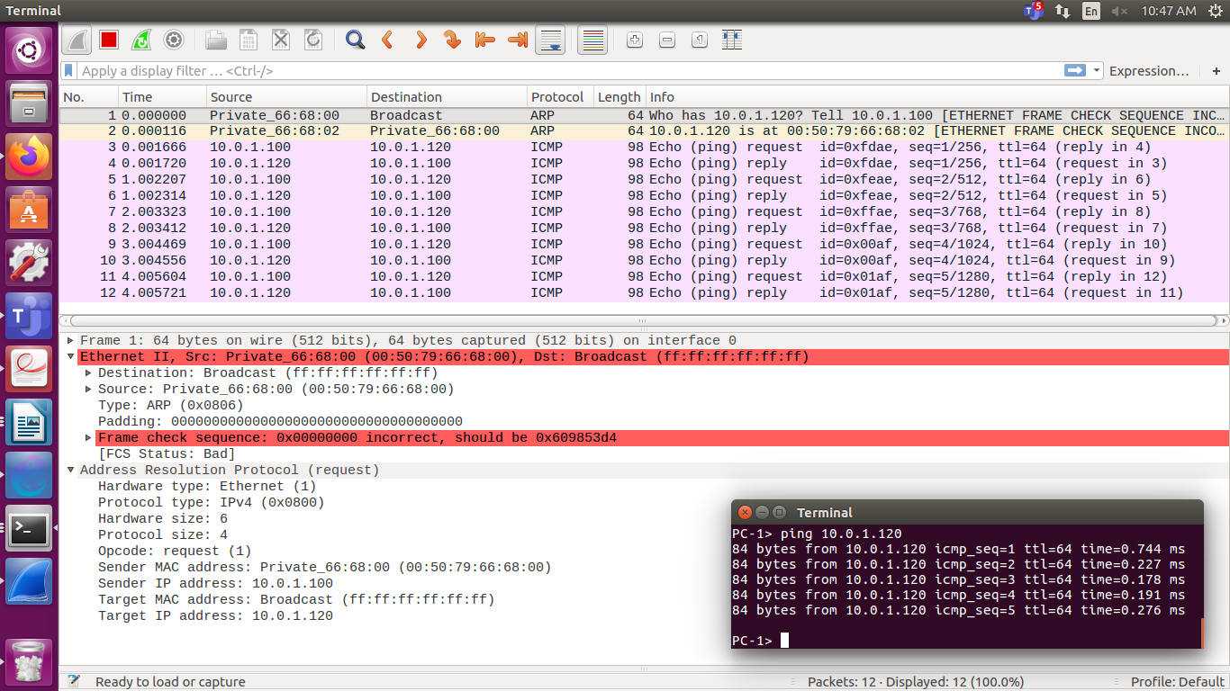

**ii.**

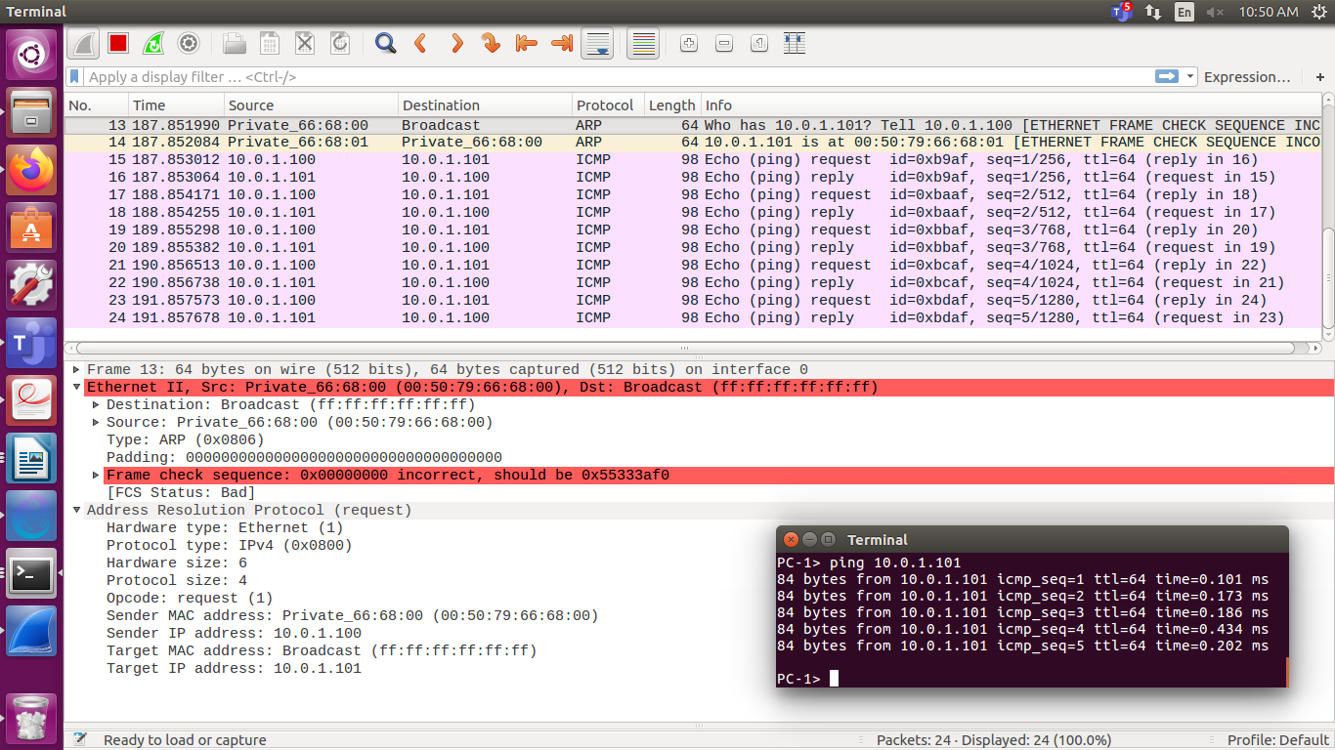

**iii.**

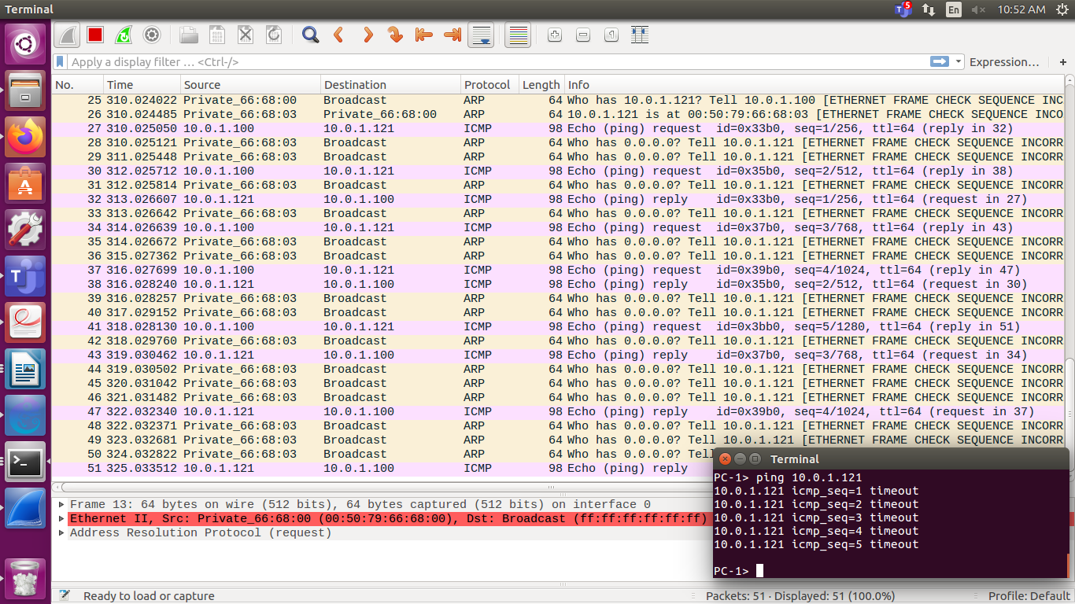

**iv.**

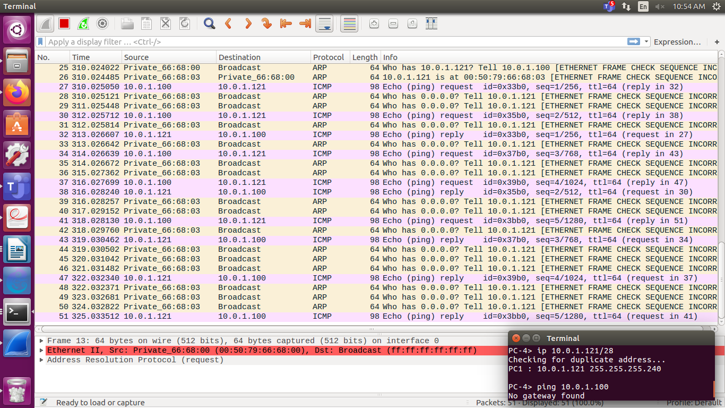

**v. and vi.**

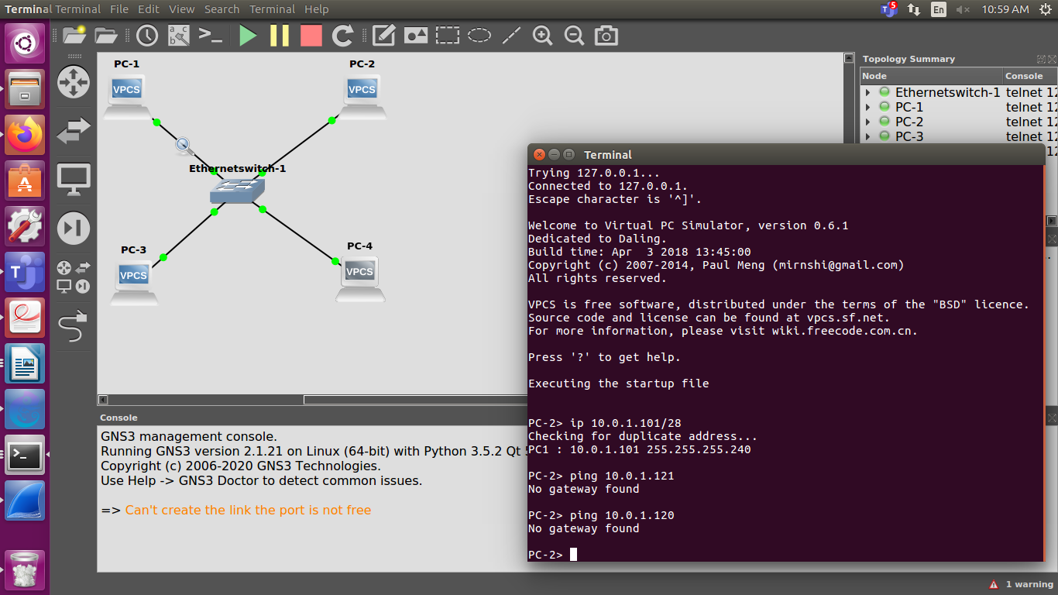

Even though their subnet masks may be the same, the network address may not lie in the same range. Thus, some PCs are not aple to ping others even when subnet mask is same.

**Question 3**

